November 12, 2019

**From your Guest Conductor:**

Congratulations on being selected as a member of the MMEA Central District Jazz Ensemble. It is an honor to be selected for this fine group and I look forward to working with you in January.

Please practice all the music thoroughly, and ask your band directors and private instructors for their input. It is very important that you come well-prepared. Pay close attention to articulation and dynamic markings.

We will be using our limited time together to fine-tune the presentation. There is an important distinction between individual preparation and group collaboration. Rather than teaching notes and rhythms, I would much prefer to address big-picture group concepts like phrasing, ensemble blend, pacing and balance. The experience will be considerably more rewarding if everyone demonstrates personal accountability by *taking care of business* beforehand.

Listening is an enjoyable, yet crucial part of preparation. I have created a special page on my

website for you, with links to recordings of the pieces I selected for us. I will include some tips and specific preparation notes on this page as well. Check back often, as I will add updates and more content.

Here is the URL:

<http://www.earlmacdonald.com/central/>

Have fun practicing, and see you in January!

Sincerely,

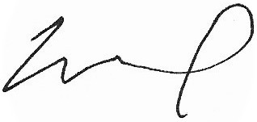

Earl MacDonald

Jazz Ensemble Director,

Professor of Jazz Studies,

University of Connecticut